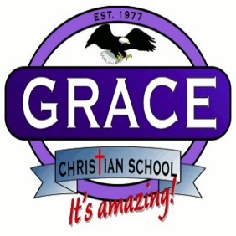
Student Chromebook Contract
The use of school-supplied Chromebooks is a privilege that comes with responsibility. Remember that the device is at all times property of the Grace Christian School, not a student’s personal device. If students notice that something is wrong with the device, they are expected to report to a teacher immediately. Failure to abide by the following guidelines may result in revoking the privilege, or further consequences.

- Only use the device, charger, and equipment that is assigned specifically to you; do not let other students use or borrow your equipment and return all parts when requested.
- Do not place books or other items on top of the device.
- Never leave your device unattended.
- Shutdown your device completely before charging the device for the next day. Your device should be completely charged at the beginning of each day.
- No food or drinks allowed around the device.
- Sound should be muted on Chromebook. Use of your headphones is permitted, when granted by the teacher.
- Only use the device for schoolwork. You must sign into your school issued Google education account. No other accounts (Google or otherwise) should be accessed on the school-issued Chromebooks at any time.
- In your classroom, carry your Chromebook using two hands.

Student Signature:_______________________________ School: _______________________

Parent Signature:________________________________ Phone:________________________

